Objective: This planning template framework is intended to be used by District Level and School-Level ICS teams to foster collaboration and increased fidelity of practice. This will help as we transition to C3 teams in the future. Feel free to modify/adjust to fit your particular school as you see fit. This template can be used as a rolling agenda/note taking guide and should be housed in your ICS shared drive.

Date/Time of Meetings: This should be agreed upon at the beginning of the school year and shared with all team members.

Attendance: Traditionally, C3 teams sign the document when the meeting is over; to get started, we will identify who should attend these meetings and who is absent.

Required Materials/Advance Preparation: Any required materials for the entire group or group leads should be listed with corresponding Advanced Preparation (Videos/module viewing, etc.)

Roles and Responsibilities: The following roles/responsibilities are a work in progress, and as we build our teams and should change at every meeting if needed, please be sure to document this for each meeting for equitable accountability & engagement from all team members (some roles will overlap, multiple times). Summarizer will work with the facilitator and recorder to create the agenda for the next meeting (this role will consistently change). Document this in action items.
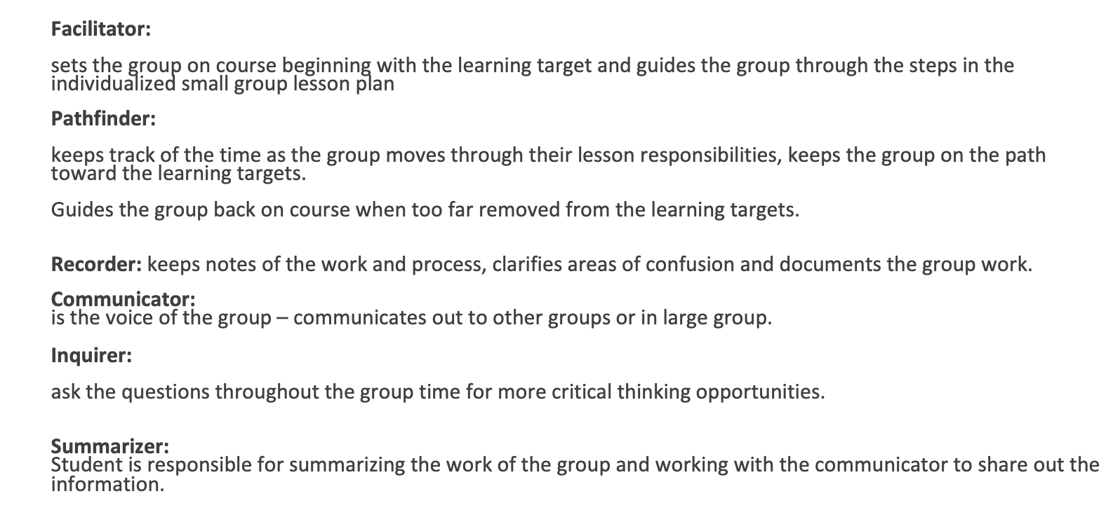
Group Agreements: At the first meeting, these should be defined with your team.

Date/Time: Location:

Required Attendees: | Absent: | Required Materials: | Advance Preparation: | Meeting Roles/Responsibility:
Facilitator:
Timekeeper/Pathfinder:
Notetaker/Recorder:
Summarizer:
Inquirer:

- Norms: Agreed upon staff norms: Non-Negotiables

- Meeting Goals/Outcomes:
  - (5-10 min.)

Topics for Discussion: | Who?: | Links: | Topic Notes: (Notetaker Completes)

Action Items:
Alignment: | Task: | Who’s Responsible: | Due Date:

